

AHDB Recommended Lists (RL) for cereals and oilseeds: Verticillium stem stripe of oilseed rape

This protocol was believed to comply with relevant agrochemical, environmental and other regulations at the time of writing but it is the responsibility of the contractor to ensure that it continues to comply. In the event of non-compliance the protocol should not be followed but the Field Trials Manager should be notified at once of how the protocol requirements would breach regulations.

Any deviation from this protocol other than under the circumstances described above may result in a breach of contract and should be agreed in advance.

While the Agriculture and Horticulture Development Board seeks to ensure that the information contained within this document is accurate at the time of printing, no warranty is given in respect thereof and, to the maximum extent permitted by law, the Agriculture and Horticulture Development Board accepts no liability for loss, damage or injury howsoever caused (including that caused by negligence) or suffered directly or indirectly in relation to information and opinions contained in or omitted from this document.

Reference herein to trade names and proprietary products without stating that they are protected does not imply that they may be regarded as unprotected and thus free for general use. No endorsement of named products is intended, nor is any criticism implied of other alternative, but unnamed, products.

AHDB Cereals & Oilseeds is a part of the Agriculture and Horticulture Development Board (AHDB).

Changes from previous version
Page no. | Section | Details of change

Contents
Each of the sections listed below can be used to navigate the document by left clicking the relevant section whilst pressing the Ctrl button at the same time.

TITLE PAGE 1
Changes from previous version 2
Contents 3
Part 1: General Information 4
Location of test 4
Source of inoculum 4
Trial type 4
Number of tests each year 4
Varieties in test 4
Assessment 4
Timing of assessment 4
Disease assessment method 5
Assessment of other diseases 5
Appendix 1 – Assessment key for Verticillium longisporum 6
Typical Verticillium stem stripe symptoms 6

Part 1: General Information

Location of test
Not specified.

Source of inoculum
The trial site can be naturally or artificially infected. There should be uniform disease distribution across the trial. Inoculation of sites, where required, should be done as follows:

- Soil should be inoculated 1-2 weeks after sowing.
- Inoculum should consist of a maize meal and vermiculite substrate which has previously been infected with UK isolates of V. longisporum and incubated at room temperature until abundant microsclerotia have formed.
- The mixture should be air dried before spreading on the test plots, using an amount calculated to give between 40-100 colony forming units cm² of soil.

Trial type
Either small (3–6m long), or larger (e.g. 12m long) plots may be used. There will be 4 replicates per variety. The trial should not go to yield. The trial should be established and maintained in line with the WR22-26 AHDB winter oilseed rape trials protocol, with the exception of fungicide treatments, where one autumn treatment to control stem canker should be used as needed.

Number of tests each year
There will be two trials per year.

Varieties in test
All RL P1 and candidate winter oilseed rape varieties, approximately 40. The sowing list will be supplied by the RL team.

Assessment

Timing of assessment
The timing of assessment is crucial. Yellowing of half a leaf (Appendix 1) is considered to be an early symptom of verticillium stripe and can be observed at the base of the canopy from the end of April onwards. From mid-June onwards plots should be inspected regularly. First symptoms of verticillium stripe are usually yellow streaks running the length of the stem or a large branch. Often, this is a single streak per stem, and it will eventually become more obvious and turn brown (Appendix 1). Symptoms should be assessed weekly during late June or early to mid-July. Symptoms can develop rapidly over a period of 7 to 14 days and the best assessment date can vary between years. Scoring too early could mean under-estimation of symptom incidence and severity, even with scraping to reveal sub-epidermal symptoms. Equally, scoring too late could mean difficulty in seeing verticillium on stems which are rapidly drying out. In crops that remain very green at the end of the season, symptoms may not be fully expressed until a few days after desiccation.

Disease assessment method
Disease assessments should be done on stems that have been removed from the plot so the entire circumference of the stem can be assessed easily. Pull up 30 stems per plot and score the middle to upper thirds of each stem for the presence of stem shredding and black microsclerotia. Stems should always be scraped to confirm whether or not infection is present. Some varieties, particularly those slower to mature, will only exhibit internal symptoms. Assign stems to infection classes defined in Table 1. Calculate an index (0-100) by multiplying the number of stems in each category by the numerical value of the category, dividing by the total number of stems, and multiplying by 100/5.

Table 1. Infection classes for severity of verticillium symptoms on oilseed rape stems.
Scale point | Description
0 | No symptoms
1 | 1-25% circumference affected
2 | 26-50% circumference affected
3 | 51-75% circumference affected
4 | >75% circumference affected
5 | Severely affected and plant dead

If no microsclerotia are visible, scrape back a section of stem so that any sub-epidermal grey discolouration typical of verticillium infection can be seen. If this is present, revise scores to take it into account.

Assessment of other diseases
If other disease such as phoma stem canker are observed, this should be noted in the trial diary, but it is not a requirement to assess diseases other than verticillium.

Appendix 1 – Assessment key for Verticillium longisporum

Typical Verticillium stem stripe symptoms
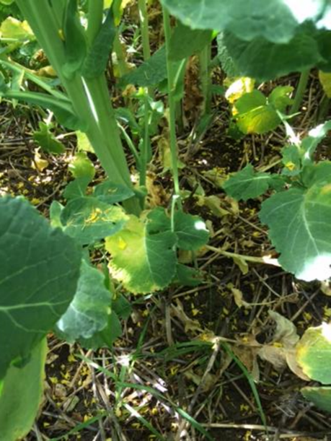 | 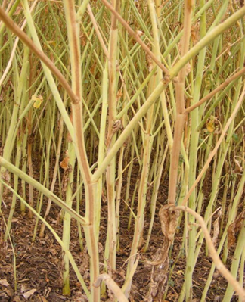
Figure 1. Early leaf symptoms of verticillium  stripe on a susceptible variety in mid-May  yellowing of half a leaf. | Figure 2. Characteristic striping along the length of the stems observed in early July.
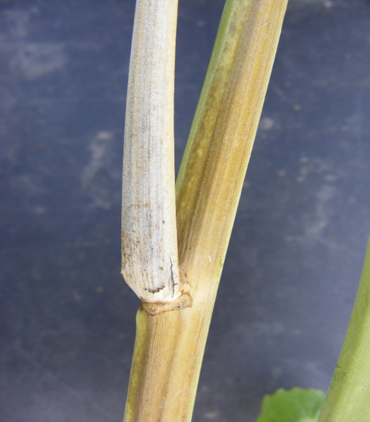 | 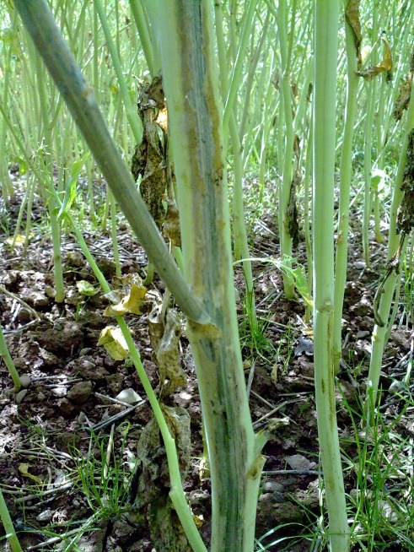
Figure 3. Close up of verticillium stripe showing  an affected branch and the distinction between  the brown stripe and green plant tissue. | Figure 4. Scraped stem reveals vascular staining  not visible on the outside of the stem.

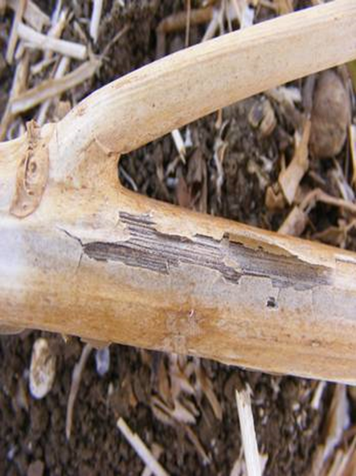
Figure 5. Microsclerotia, exposed due to the
stem surface becoming dried out, paper-like
and splitting, on winter oilseed rape in mid-July.

Contact us
AHDB, Siskin Parkway East, Middlemarch Business Park, Coventry CV3 4PE
Email: info@ahdb.org.uk

